**DAILY ONLINE ACTIVITIES SUMMARY**

|  |  |  |  |  |  |  |  |  |
| --- | --- | --- | --- | --- | --- | --- | --- | --- |
| **Date:** | **19/05/2020** | | | | | **Name:** | **NAIPUNYA VINOD NAIK** | |
| **Sem & Sec** | **IV A** | | | | | **USN:** | **4AL18CS050** | |
| **Online Test Summary** | | | | | | | | |
| **Subject** | | **DESIGN AND ANALYSIS OF ALGORITHMS** | | | | | | |
| **Max. Marks** | | **30** | | **Score** | | | **23** | |
| **Certification Course Summary** | | | | | | | | |
| **Course** | **INTRODUCTION TO HADOOP** | | | | | | | |
| **Certificate Provider** | | | **GREAT LEARNING ACADEMY** | | **Duration** | | | **5.5 HRS** |
| **Coding Challenges** | | | | | | | | |
| **Problem Statement:** A user will input two strings, and we find if one of the strings is a sub sequence of the other. Program prints “yes” if either the first string is a sub sequence of the second string or the second string is a sub sequence of the first string. Assume that, the length of the first string is smaller than or equal to the length of the second string.  **An expected output of the program:**  Input the first string tree Input the second string Computer science is awesome YES | | | | | | | | |
| **Status: COMPLETED** | | | | | | | | |
| **Uploaded the report in Github** | | | | | **YES** | | | |
| **If yes Repository name** | | | | | <https://github.com/naiknaipu/lockdown-coding/blob/master/SUBSEQUENCE.c> | | | |
| **Uploaded the report in slack** | | | | | **YES** | | | |

Online Test Details: (Attach the snapshot and briefly write the report for the same)

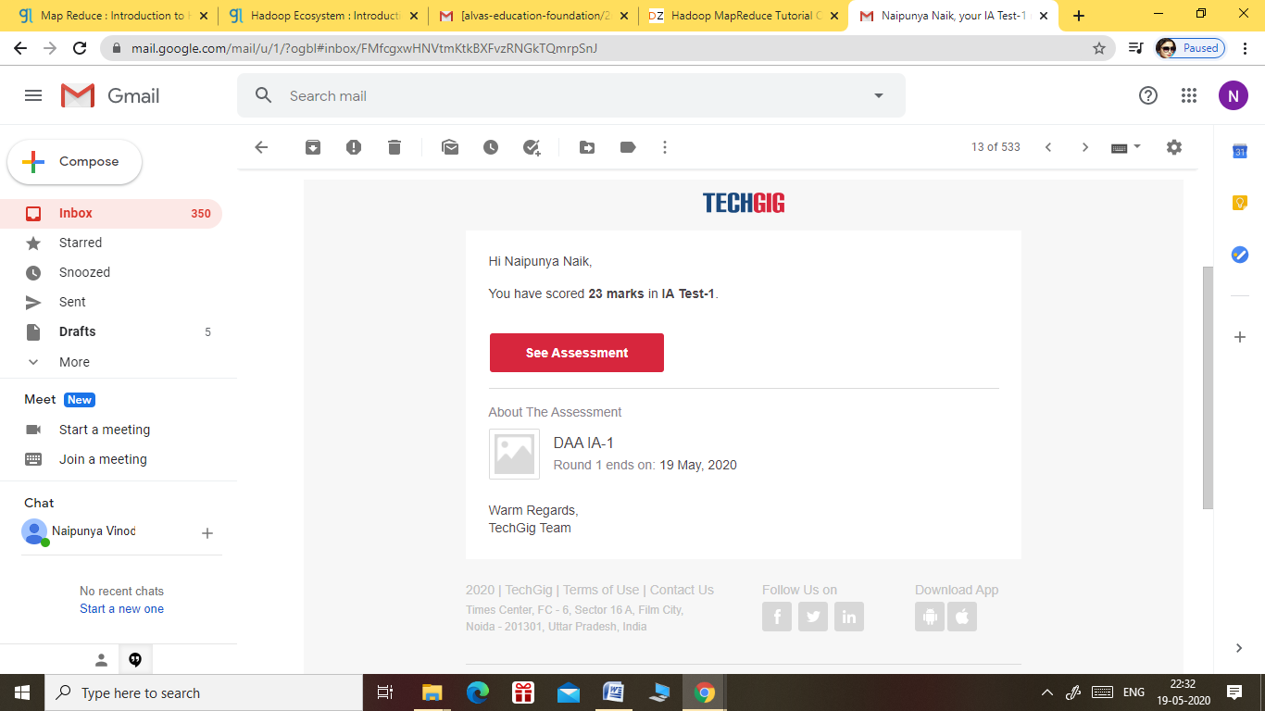

DESIGN AND ANALYSIS OF ALGORITHMS 1ST I.A TEST

* THE TEST WAS OF 30 MIN DURATION
* THE TEST COMPRISED THE CONCEPTS OF MODULE-1
* THE TEST COMPRISED 20 QUESTIONS OF 1 MARK AND 5 QUESTIONS OF 2 MARKS.

Certification Course Details: (Attach the snapshot and briefly write the report for the same)

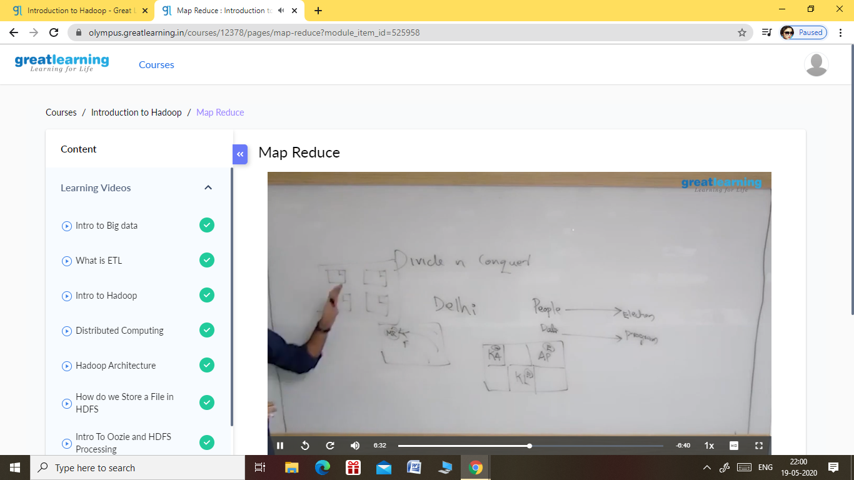

REPORT CAN BE TYPED OR HANDWRITTEN UPTO TWO PAGES

TOPICS LEARNT TODAY:

* HADOOP CLUSTER HANDS ON

1. LEARNT HOW TO ANALYSE BIG DATA WITH HADOOP

2. LEARNT HOW TO SETUP AN APACHE CLUSTER ON HADOOP

* HADOOP ECOSYSTEM

1. LEARNT ABOUT WHAT IS HADOOP ECOSYSTEM?

2. LEARNT ABOUT HOW TO USE HADOOP TOOLS FOR CRUNCHING BIG DATA.

3. LEARNT ABOUT HADOOP ECOSYSTEM AND THEIR COMPONENTS.

* MAP REDUCE

1. LEARNT ABOUT HADOOP MAP REDUCE PROGRAMMING PARADIGM.
2. LEARNT ABOUT MAP REDUCE REAL LIFE EXAMPLES.
3. LEARNT ABOUT MAP REDUCE ARCHITECTURE.

Coding Challenges Details: (Attach the snapshot and briefly write the report for the same)

CODE UPLOADED ON GITHUB:-

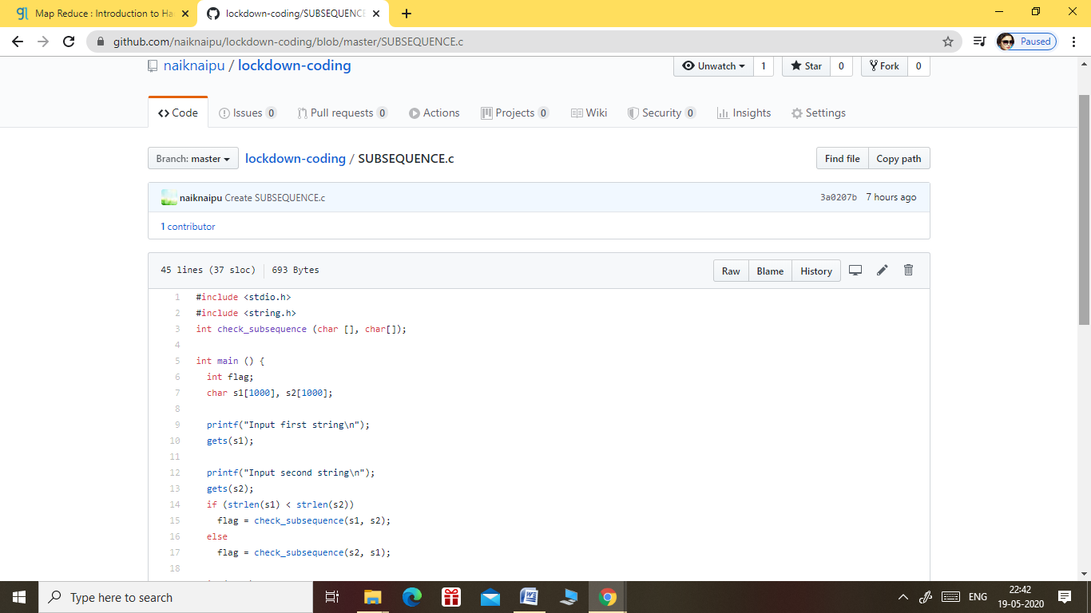

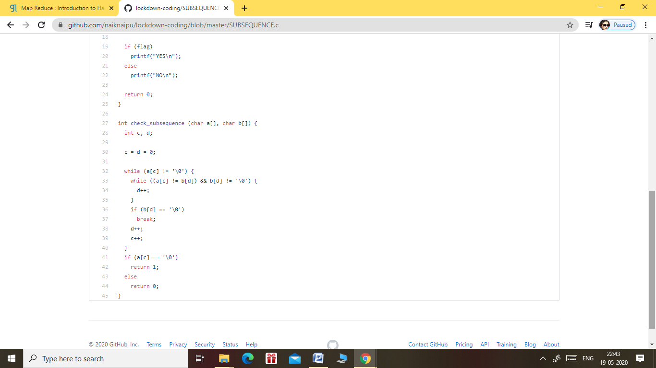

OUTPUT FOR THE SUBSEQUENCE PROGRAM:-

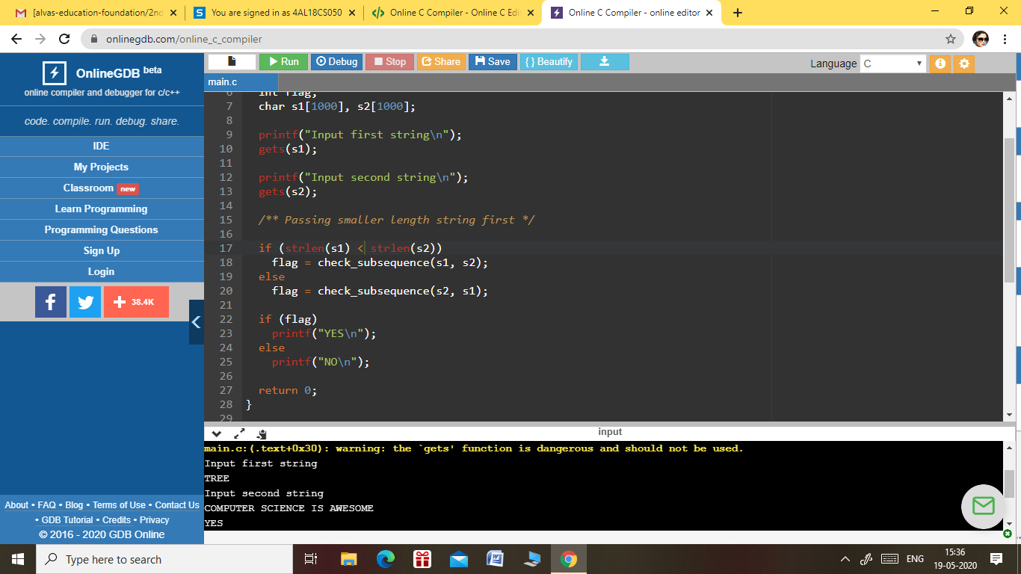

TOPICS LEARNT FROM CODING PROGRAM

* LEARNT ABOUT STRINGS.
* APPLIED IF ELSE CONDITION FOR THE EXECUTION OF PROGRAM.
* LEARNT THE USE OF FLAG STATEMENTS.